1. 
2. Rebasing is actually Two-Step Process.
   1. **1st**: Rebase feature branch on top of base branch (master, release).
   2. **2nd**: Merge feature branch into base branch (master, release).
3. 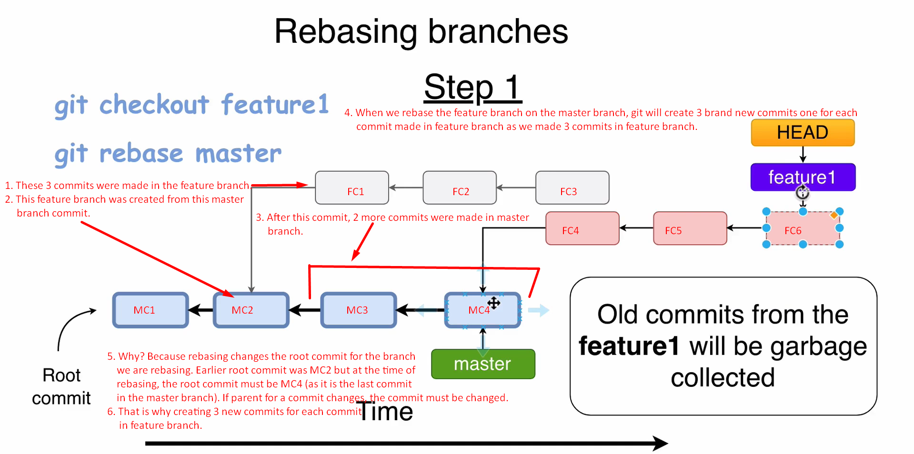
4. **Why to rebase**?
   1. Actually, we want to do fast-forward merge as then the Git History is linear means only one parent commit unlike multiple parents (commits) in case of 3-way merge.
5. **What will happen to those earlier commits (FC1, FC2, FC3) after rebasing?**
   1. Those will be garbage collected by GIT as new branch referencing them.
   2. If you have SHA1, then you can check it out.